Great Rhombicuboctahedron
# Source: AI Source: Provided by: [Data Path: Persons Table -> ID Column: 1, Name_En Column: Motasem Essam] -> From: [ChatGPT] on [7/25/2026]
Naming clarification: The name Great Rhombicuboctahedron is used for more than one polyhedron. Since this topic is under Uniform Star Polyhedra, this document covers the non-convex Great Rhombicuboctahedron, also called the Quasirhombicuboctahedron (U₁₇, Wenninger index 85). It is different from the convex Archimedean solid also called the Great Rhombicuboctahedron.

Definition
# Source: AI Source: Provided by: [Data Path: Persons Table -> ID Column: 1, Name_En Column: Motasem Essam] -> From: [ChatGPT] on [7/25/2026]
The Quasirhombicuboctahedron, also known in some references as the Great Rhombicuboctahedron, is a non-convex uniform polyhedron composed of 26 regular polygonal faces: 8 equilateral triangles and 18 squares.
It has 24 vertices and 48 edges. Its defining characteristic is a non-convex arrangement of faces that includes a crossed triangular contribution in its vertex configuration.
Its identifiers include:
- Uniform Polyhedron Index: U₁₇
- Wenninger Index: W₈₅
- Coxeter Index: C₅₉
- Bowers Acronym: Querco
- Wythoff Symbol: $\frac{3}{2} 4∣2$

Geometric Representation
# Source: AI Source: Provided by: [Data Path: Persons Table -> ID Column: 1, Name_En Column: Motasem Essam] -> From: [ChatGPT] on [7/25/2026]
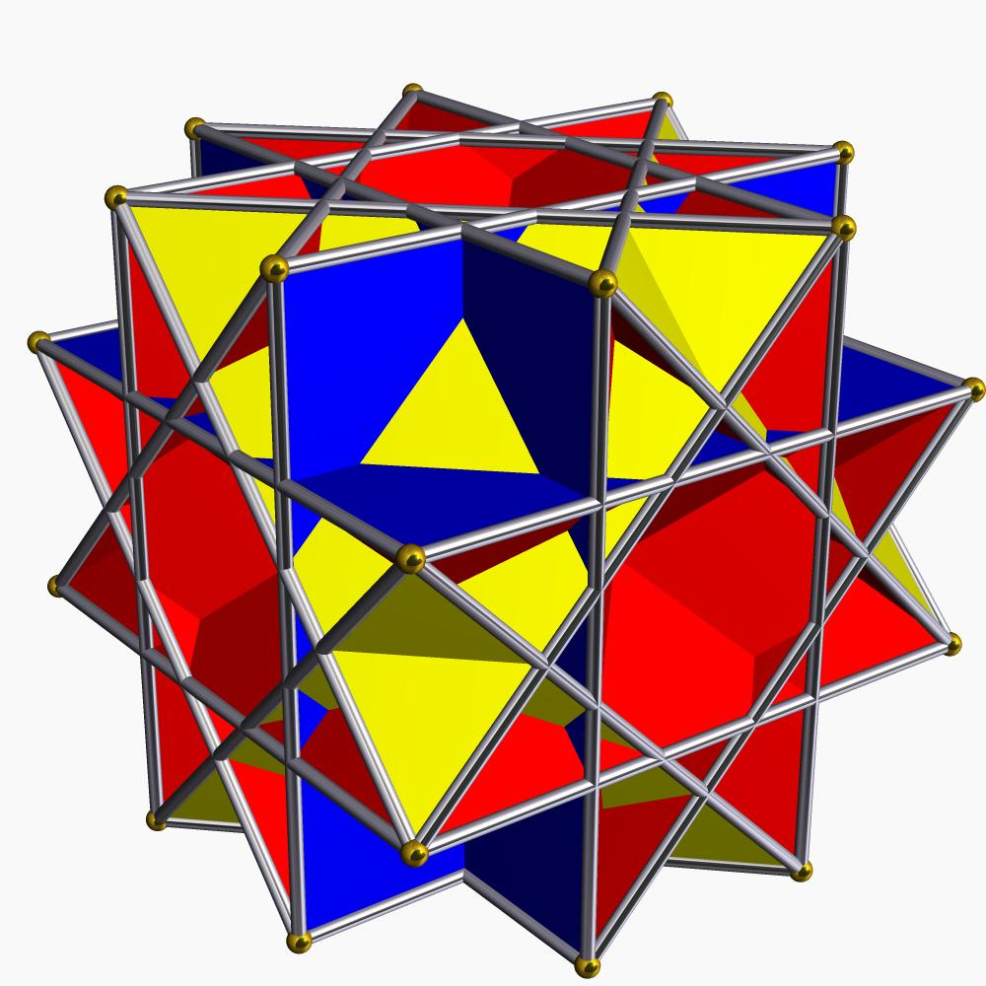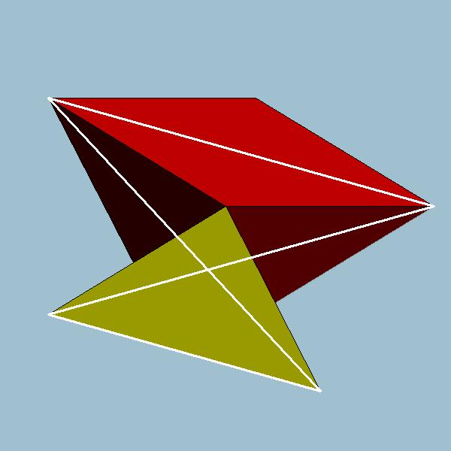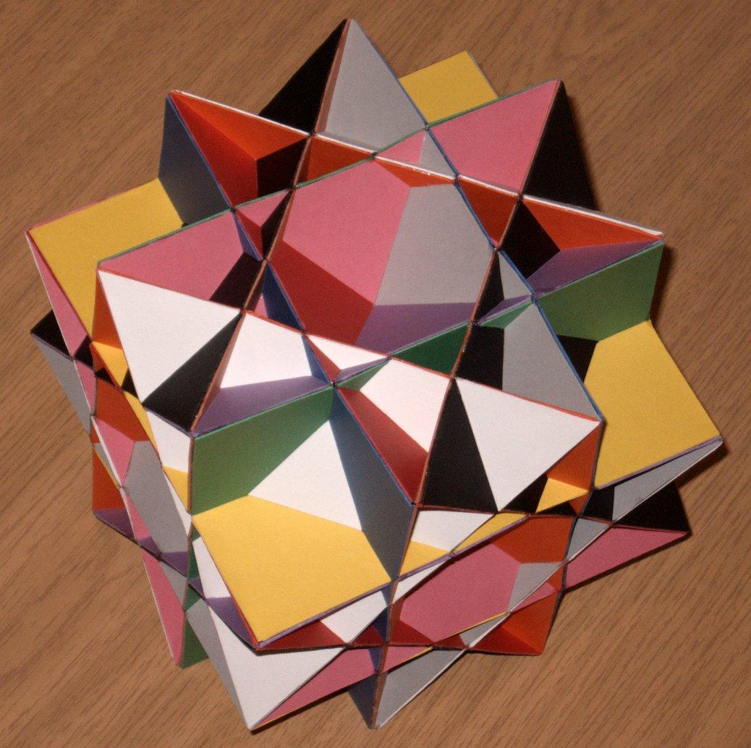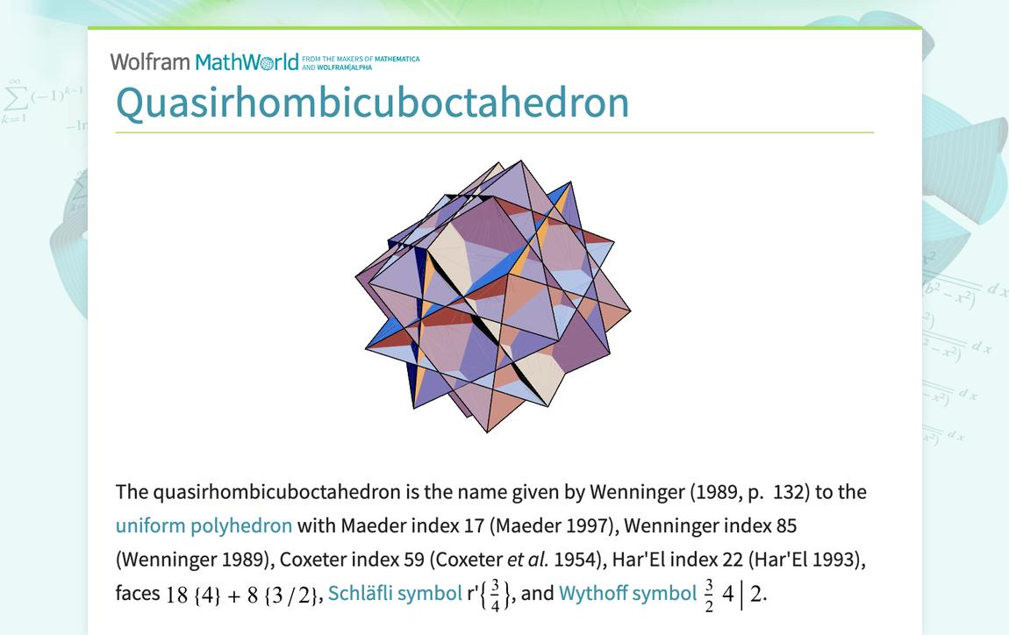

Geometric Structure
# Source: AI Source: Provided by: [Data Path: Persons Table -> ID Column: 1, Name_En Column: Motasem Essam] -> From: [ChatGPT] on [7/25/2026]
The Quasirhombicuboctahedron has a non-convex arrangement of triangular and square faces.
Its main structural characteristics are:
- Triangular faces: 8 equilateral triangles.
- Square faces: 18 squares.
- Edges: 48.
- Vertices: 24.
- Crossed vertex arrangement: Its vertex figure is a crossed quadrilateral.
- Face intersections: Its non-convex arrangement creates intersecting geometric regions.
- Uniformity: All vertices are equivalent under its symmetry group.
It shares its vertex-edge skeleton with the small rhombicuboctahedron, but its face arrangement differs.

Mathematical Properties
# Source: AI Source: Provided by: [Data Path: Persons Table -> ID Column: 1, Name_En Column: Motasem Essam] -> From: [ChatGPT] on [7/25/2026]
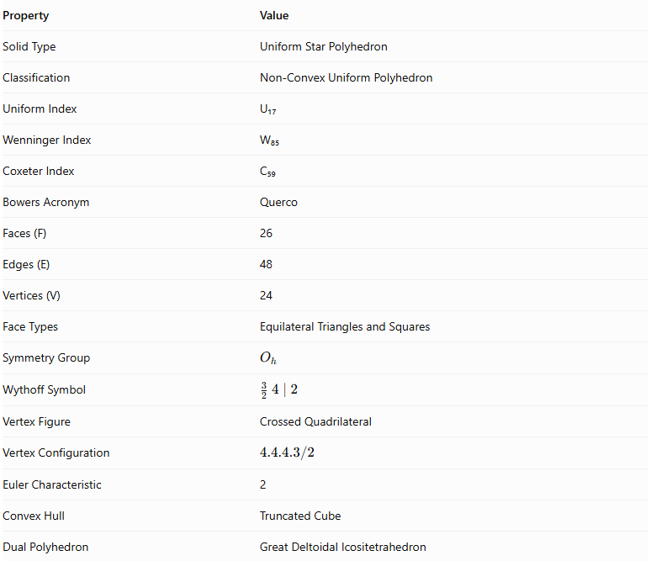
Property | Value
Solid Type | Uniform Star Polyhedron
Classification | Non-Convex Uniform Polyhedron
Uniform Index | U₁₇
Wenninger Index | W₈₅
Coxeter Index | C₅₉
Bowers Acronym | Querco
Faces (F) | 26
Edges (E) | 48
Vertices (V) | 24
Face Types | Equilateral Triangles and Squares
Symmetry Group | $$O_{h}$$
Wythoff Symbol | $$\frac{3}{2} 4∣2$$
Vertex Figure | Crossed Quadrilateral
Vertex Configuration | $$4.4.4.3/2$$
Euler Characteristic | 2
Convex Hull | Truncated Cube
Dual Polyhedron | Great Deltoidal Icositetrahedron

Face Composition
# Source: AI Source: Provided by: [Data Path: Persons Table -> ID Column: 1, Name_En Column: Motasem Essam] -> From: [ChatGPT] on [7/25/2026]
The Quasirhombicuboctahedron contains 26 faces distributed among two polygon types.
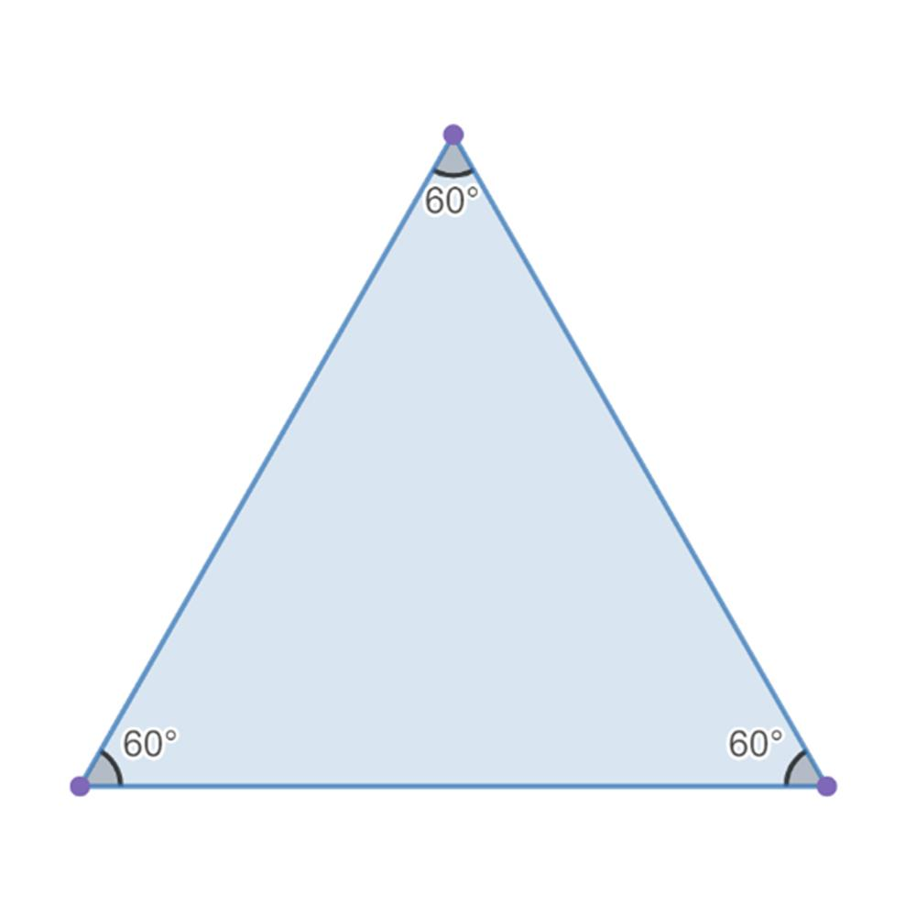
Equilateral Triangles
8
Three equal sides and three 60° angles.
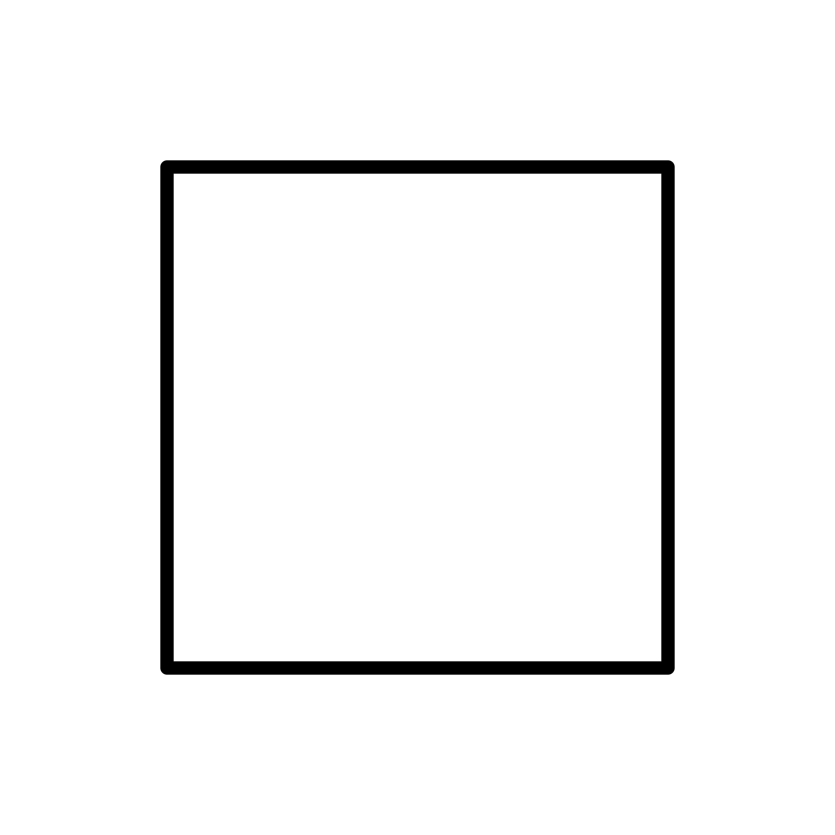
Squares
18
Four equal sides and four 90° angles.
The face composition is represented by:
$$\boxed{8\{3\}+18\{4\}}$$
Where:
- $\{3\}$ represents an equilateral triangle.
- $\{4\}$ represents a square.
Although its faces are ordinary triangles and squares, their spatial arrangement produces the non-convex structure.

Vertex Configuration
# Source: AI Source: Provided by: [Data Path: Persons Table -> ID Column: 1, Name_En Column: Motasem Essam] -> From: [ChatGPT] on [7/25/2026]
The Quasirhombicuboctahedron has 24 equivalent vertices.
Its vertex figure is a crossed quadrilateral, and its vertex configuration is:
$$\boxed{4.4.4.\frac{3}{2}}$$
This represents the local arrangement of three square contributions and a crossed triangular contribution around each vertex.
The crossed arrangement distinguishes it from the convex small rhombicuboctahedron, even though both have the same number of vertices and edges.

Construction
# Source: AI Source: Provided by: [Data Path: Persons Table -> ID Column: 1, Name_En Column: Motasem Essam] -> From: [ChatGPT] on [7/25/2026]
The Quasirhombicuboctahedron can be understood as a non-convex uniform arrangement using the vertex-edge skeleton of the small rhombicuboctahedron.
Its construction can be described as follows:
- Begin with the 24-vertex arrangement associated with the small rhombicuboctahedron.
- Retain the 48-edge skeleton.
- Arrange 18 square faces around the vertices.
- Arrange 8 equilateral triangular faces in the remaining face positions.
- Use the crossed vertex arrangement specified by its uniform configuration.
- Extend the face arrangement symmetrically to produce the non-convex polyhedron.
The resulting solid has 26 faces, 48 edges, and 24 vertices.

Geometric Dimensions and Formulas
# Source: AI Source: Provided by: [Data Path: Persons Table -> ID Column: 1, Name_En Column: Motasem Essam] -> From: [ChatGPT] on [7/25/2026]
Let:
- $a$ = common edge length.
- $A_{3}$ = area of one equilateral triangular face.
- $A_{4}$ = area of one square face.
- $S$ = sum of the individual face areas.
- $R$ = circumradius.
Equilateral triangular face area:
$$A_{3}=\frac{\sqrt{3}}{4}a^{2}$$
Square face area:
$$A_{4}=a^{2}$$
Sum of the individual face areas:
$$S=8A_{3}+18A_{4}$$
Substituting:
$$S=8(\frac{\sqrt{3}}{4}a^{2})+18a^{2}$$
Therefore:
$$\boxed{S=(18+2\sqrt{3})a^{2}}$$
This is the sum of the individual face areas, not necessarily the exposed external boundary area.
Circumradius:
For a unit edge length:
$$R=\frac{1}{2}\sqrt{5-2\sqrt{2}}$$
For a general edge length:
$$\boxed{R=\frac{a}{2}\sqrt{5-2\sqrt{2}}}$$

Euler Characteristic
# Source: AI Source: Provided by: [Data Path: Persons Table -> ID Column: 1, Name_En Column: Motasem Essam] -> From: [ChatGPT] on [7/25/2026]
Using the conventional numbers of vertices, edges, and faces:
$$χ=V-E+F$$
Substituting:
$$χ=24-48+26$$
$$\boxed{χ=2}$$
This is the Euler characteristic of its combinatorial surface. Despite its non-convex geometric arrangement, its underlying surface has the topology of a sphere.

Symmetry
# Source: AI Source: Provided by: [Data Path: Persons Table -> ID Column: 1, Name_En Column: Motasem Essam] -> From: [ChatGPT] on [7/25/2026]
The Quasirhombicuboctahedron has full octahedral symmetry.
Its symmetry group is:
$$\boxed{O_{h}}$$
Its symmetry includes:
- Rotational symmetry associated with the cube and octahedron.
- Reflection symmetry.
- Inversion symmetry.
- Equivalent vertices under its symmetry transformations.

Constructing a Great Rhombicuboctahedron

Geometric Instruments
# Source: AI Source: Provided by: [Data Path: Persons Table -> ID Column: 1, Name_En Column: Motasem Essam] -> From: [ChatGPT] on [7/25/2026]
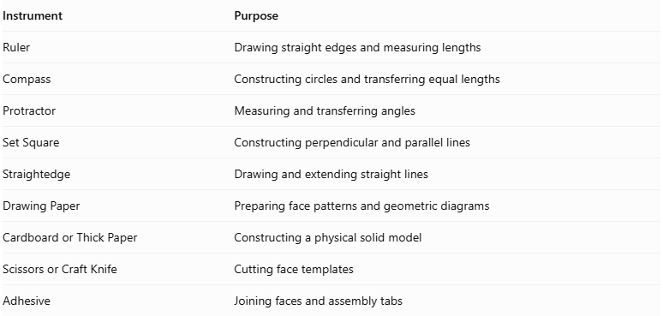
Instrument | Purpose
Ruler | Drawing straight edges and measuring lengths
Compass | Constructing circles and transferring equal lengths
Protractor | Measuring and transferring angles
Set Square | Constructing perpendicular and parallel lines
Straightedge | Drawing and extending straight lines
Drawing Paper | Preparing face patterns and geometric diagrams
Cardboard or Thick Paper | Constructing a physical solid model
Scissors or Craft Knife | Cutting face templates
Adhesive | Joining faces and assembly tabs

Instrument-Based Construction Procedures

Method 1: Construction Using Elementary Right Pyramids
# Source: AI Source: Provided by: [Data Path: Persons Table -> ID Column: 1, Name_En Column: Motasem Essam] -> From: [ChatGPT] on [7/25/2026]
This method constructs the solid from 26 right pyramids that share a common apex at the center. Each pyramid has one polygonal base corresponding to one face of the Great Rhombicuboctahedron.
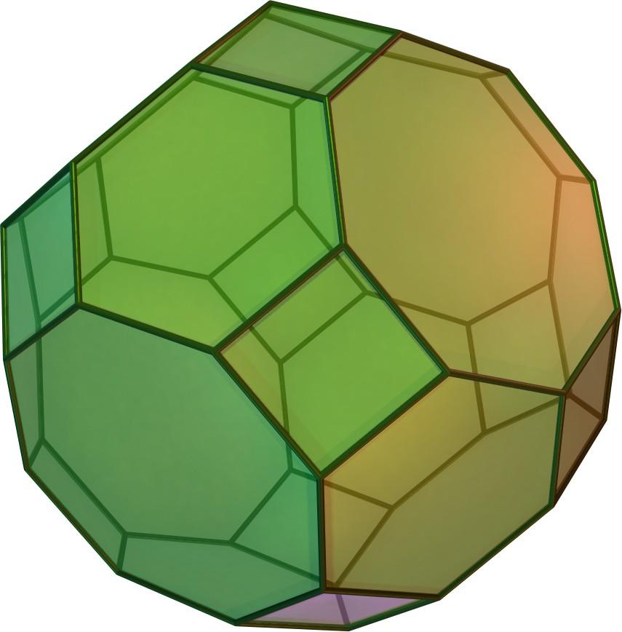
Let $a$ represent the common edge length.
Step 1: Construct 12 Square-Based Pyramids
- Draw 12 congruent squares, each with side length $a$.
- Locate the center of each square using its diagonals.
- Construct a perpendicular axis through each center.
- Mark the apex at the required normal height:
$$H_{s}=\frac{3+\sqrt{2}}{2}a$$
$$H_{s}≈2.2071a$$
Step 2: Construct 8 Hexagonal-Based Pyramids
- Construct 8 regular hexagons with side length $a$.
- Locate each hexagon's center.
- Draw a perpendicular axis through each center.
- Mark the apex at:
$$H_{h}=\frac{\sqrt{3}(1+\sqrt{2})}{2}a$$
$$H_{h}≈2.0908a$$
Step 3: Construct 6 Octagonal-Based Pyramids
- Construct 6 regular octagons with side length $a$.
- Locate each octagon's center.
- Draw a perpendicular axis through each center.
- Mark the apex at:
$$H_{o}=\frac{1+2\sqrt{2}}{2}a$$
$$H_{o}≈1.9142a$$
Step 4: Assemble the Pyramids
- Bring all 26 pyramid apexes together at one common point.
- Arrange the bases in the required orientations.
- Join their lateral surfaces according to the Great Rhombicuboctahedron's face arrangement.
- Ensure that the square, hexagonal, and octagonal bases form the external surface.
- Verify that every shared edge has length $a$.
Step 5: Verify the Completed Solid
- Count the 12 square faces.
- Count the 8 hexagonal faces.
- Count the 6 octagonal faces.
- Check that 48 vertices and 72 edges are present.
- Confirm that one square, one hexagon, and one octagon meet at each vertex.

Method 2: Construction by Expanding a Truncated Cube
# Source: AI Source: Provided by: [Data Path: Persons Table -> ID Column: 1, Name_En Column: Motasem Essam] -> From: [ChatGPT] on [7/25/2026]
This method starts with a truncated cube and expands its face arrangement to form the Great Rhombicuboctahedron.
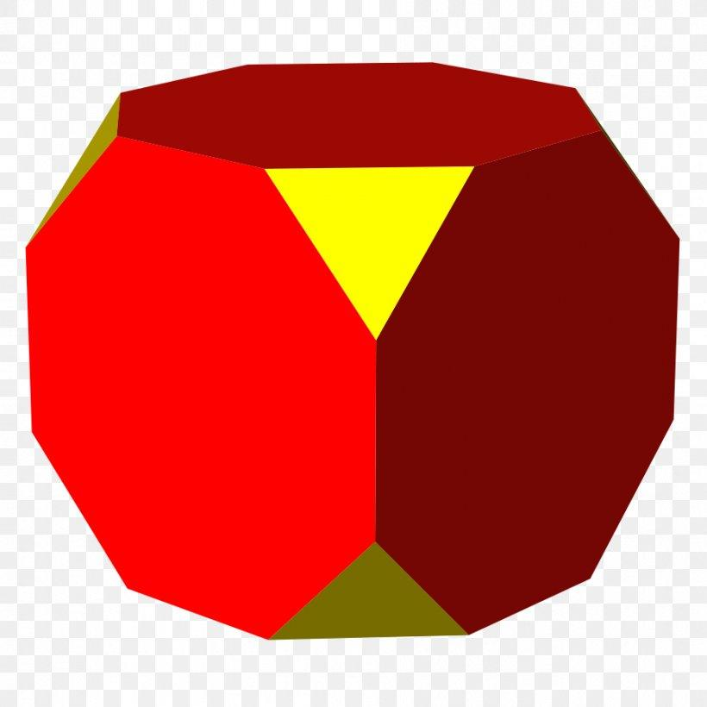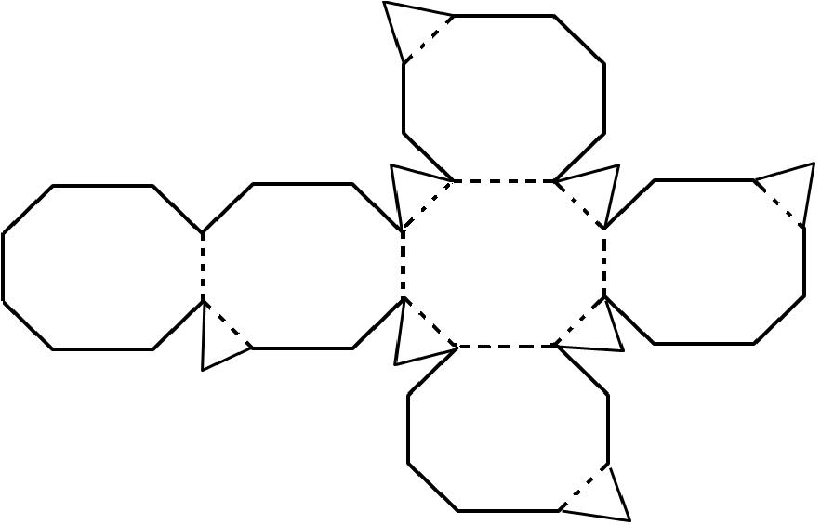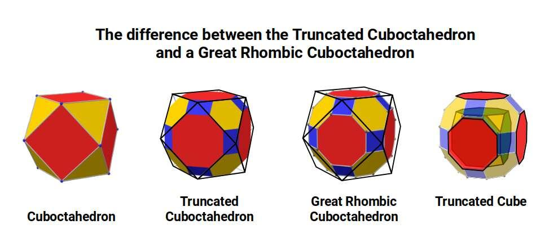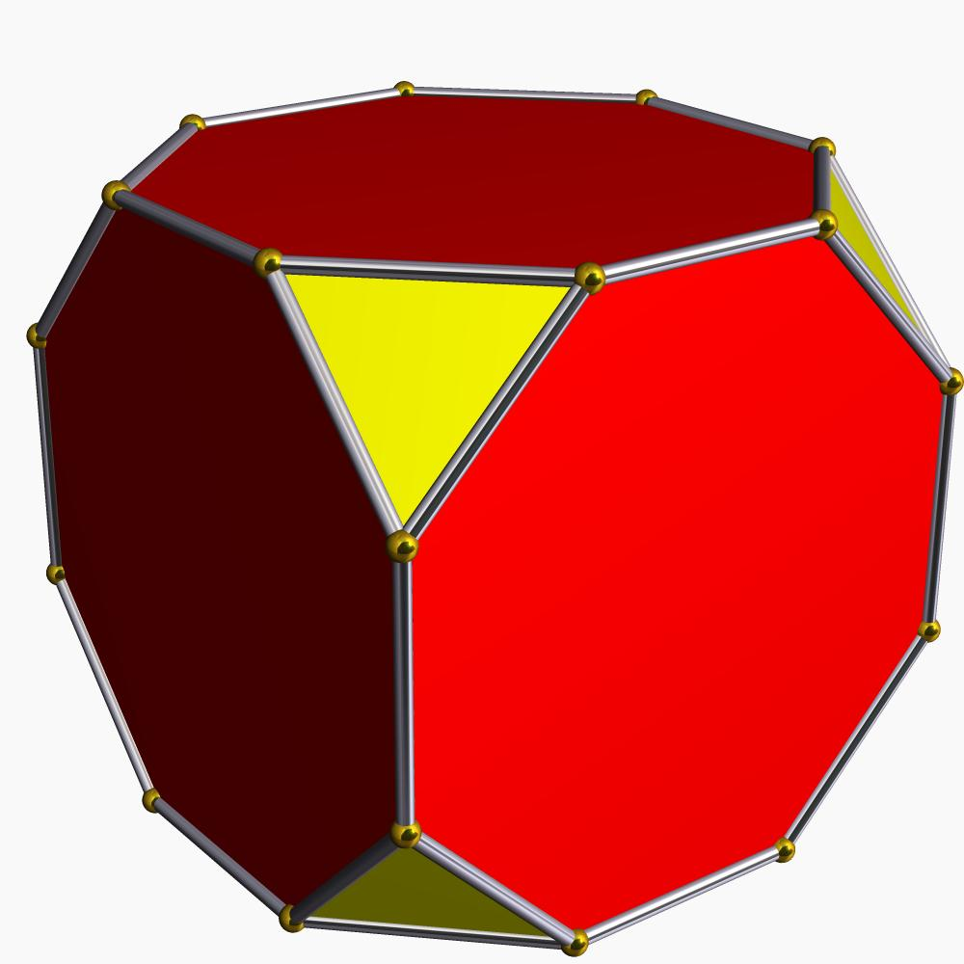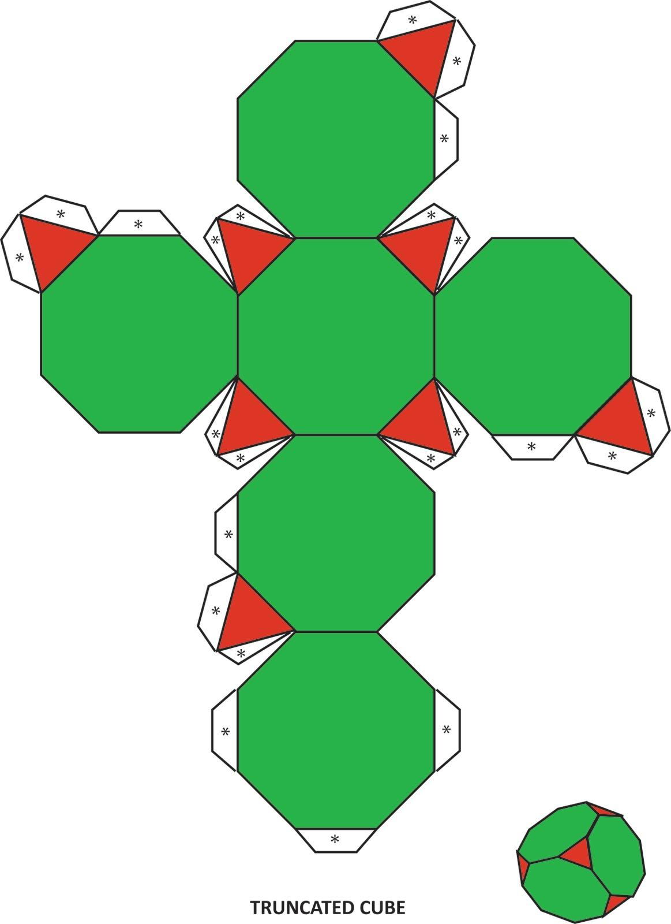
Step 1: Construct a Truncated Cube
- Draw a cube using a ruler and set square.
- Mark equal truncation distances along its edges.
- Cut off the eight original vertices using suitable planes.
- Identify the resulting 8 triangular faces, 6 octagonal faces, and 12 truncated-edge regions.
Step 2: Identify the Face Groups
- Mark the 8 triangular faces.
- Mark the 6 octagonal faces.
- Identify the 12 regions corresponding to the original cube edges.
Step 3: Expand the Face Arrangement
- Expand the triangular face regions into regular hexagonal faces.
- Transform the 12 truncated-edge regions into square faces.
- Preserve the six octagonal face orientations while moving them outward into their final positions.
- Maintain the common edge length throughout the construction.
Step 4: Connect the Expanded Faces
- Join the 12 squares to the 8 hexagons and 6 octagons.
- Align their edges and vertices.
- Verify the $4.6.8$ vertex configuration.
Step 5: Complete the Solid
- Draw the visible edges.
- Remove unnecessary construction lines.
- Check the solid from multiple viewing directions.
Note: This is a geometric expansion procedure. The exact expansion distances and face placements must be controlled to preserve regular polygons and equal edge lengths; simply enlarging the truncated cube uniformly will not produce the required solid.

Method 3: Construction Using a Physical Sphere and Face Cutting
# Source: AI Source: Provided by: [Data Path: Persons Table -> ID Column: 1, Name_En Column: Motasem Essam] -> From: [ChatGPT] on [7/25/2026]
This method is suitable for workshop or physical-model construction.
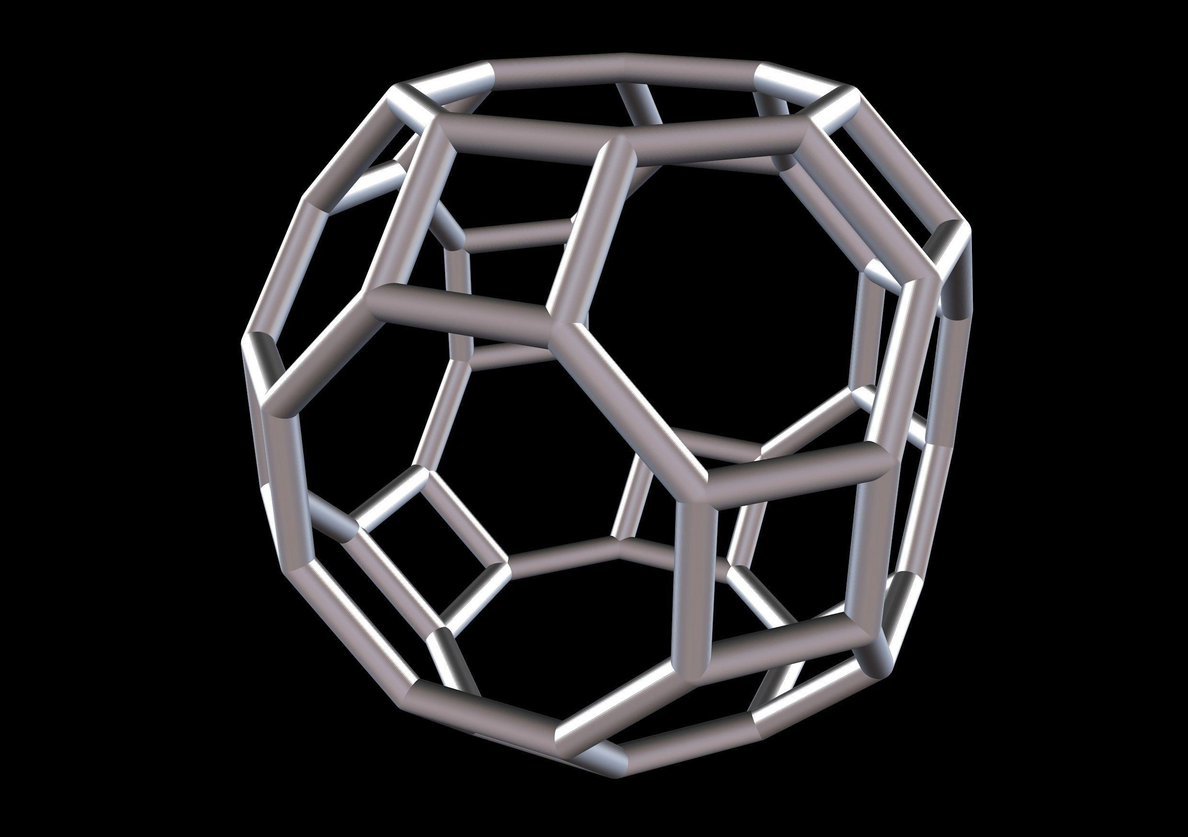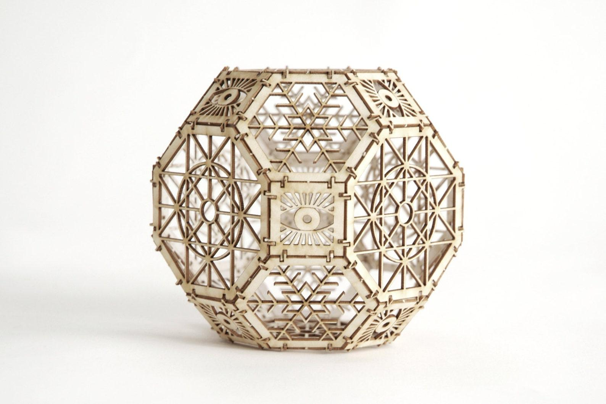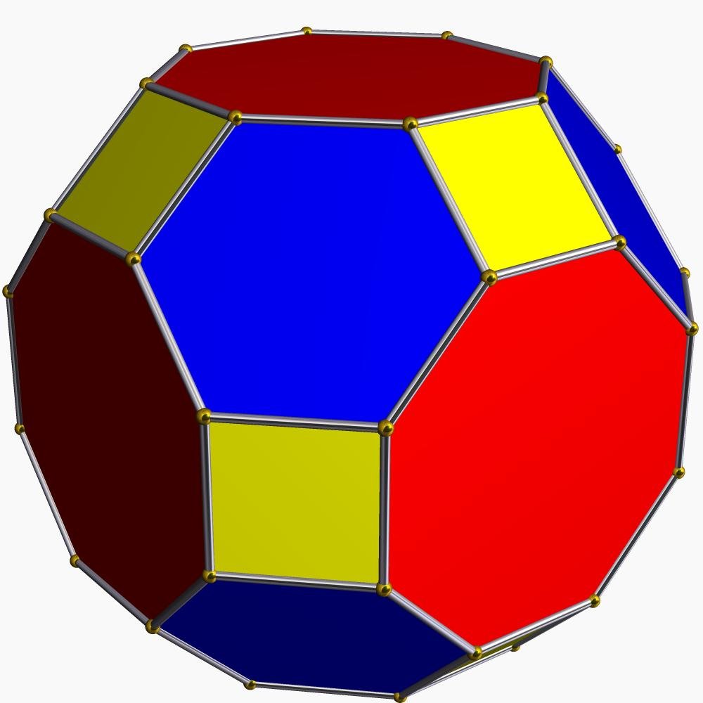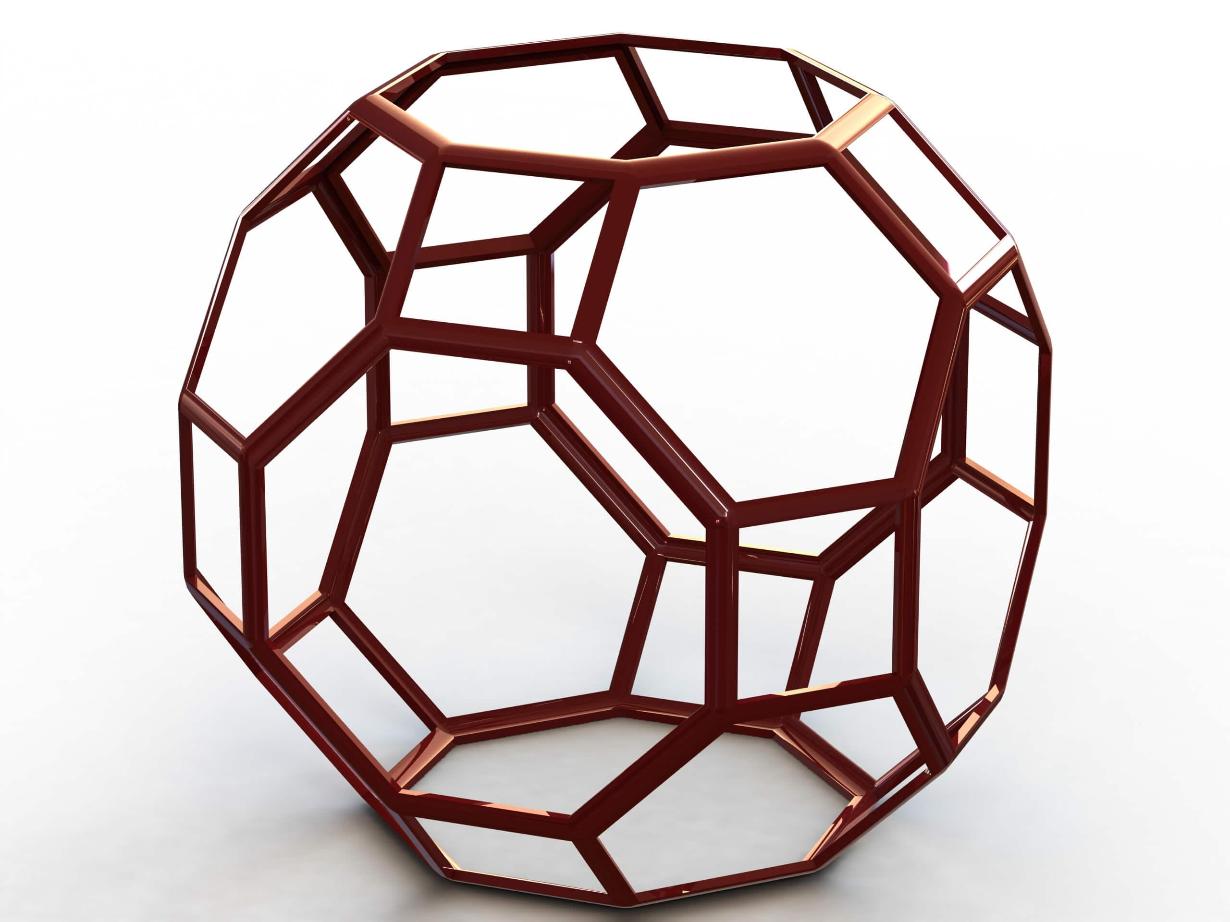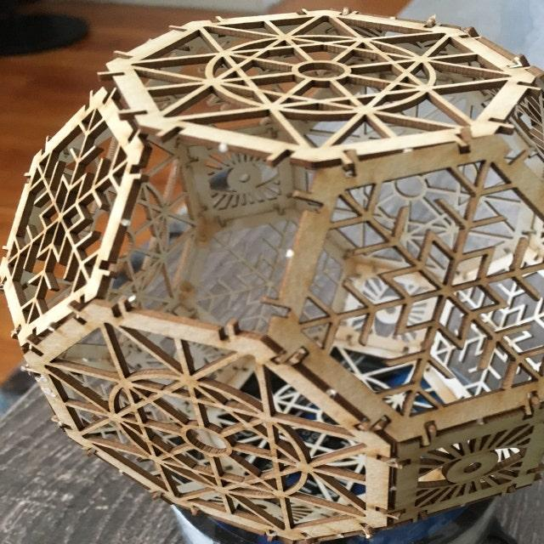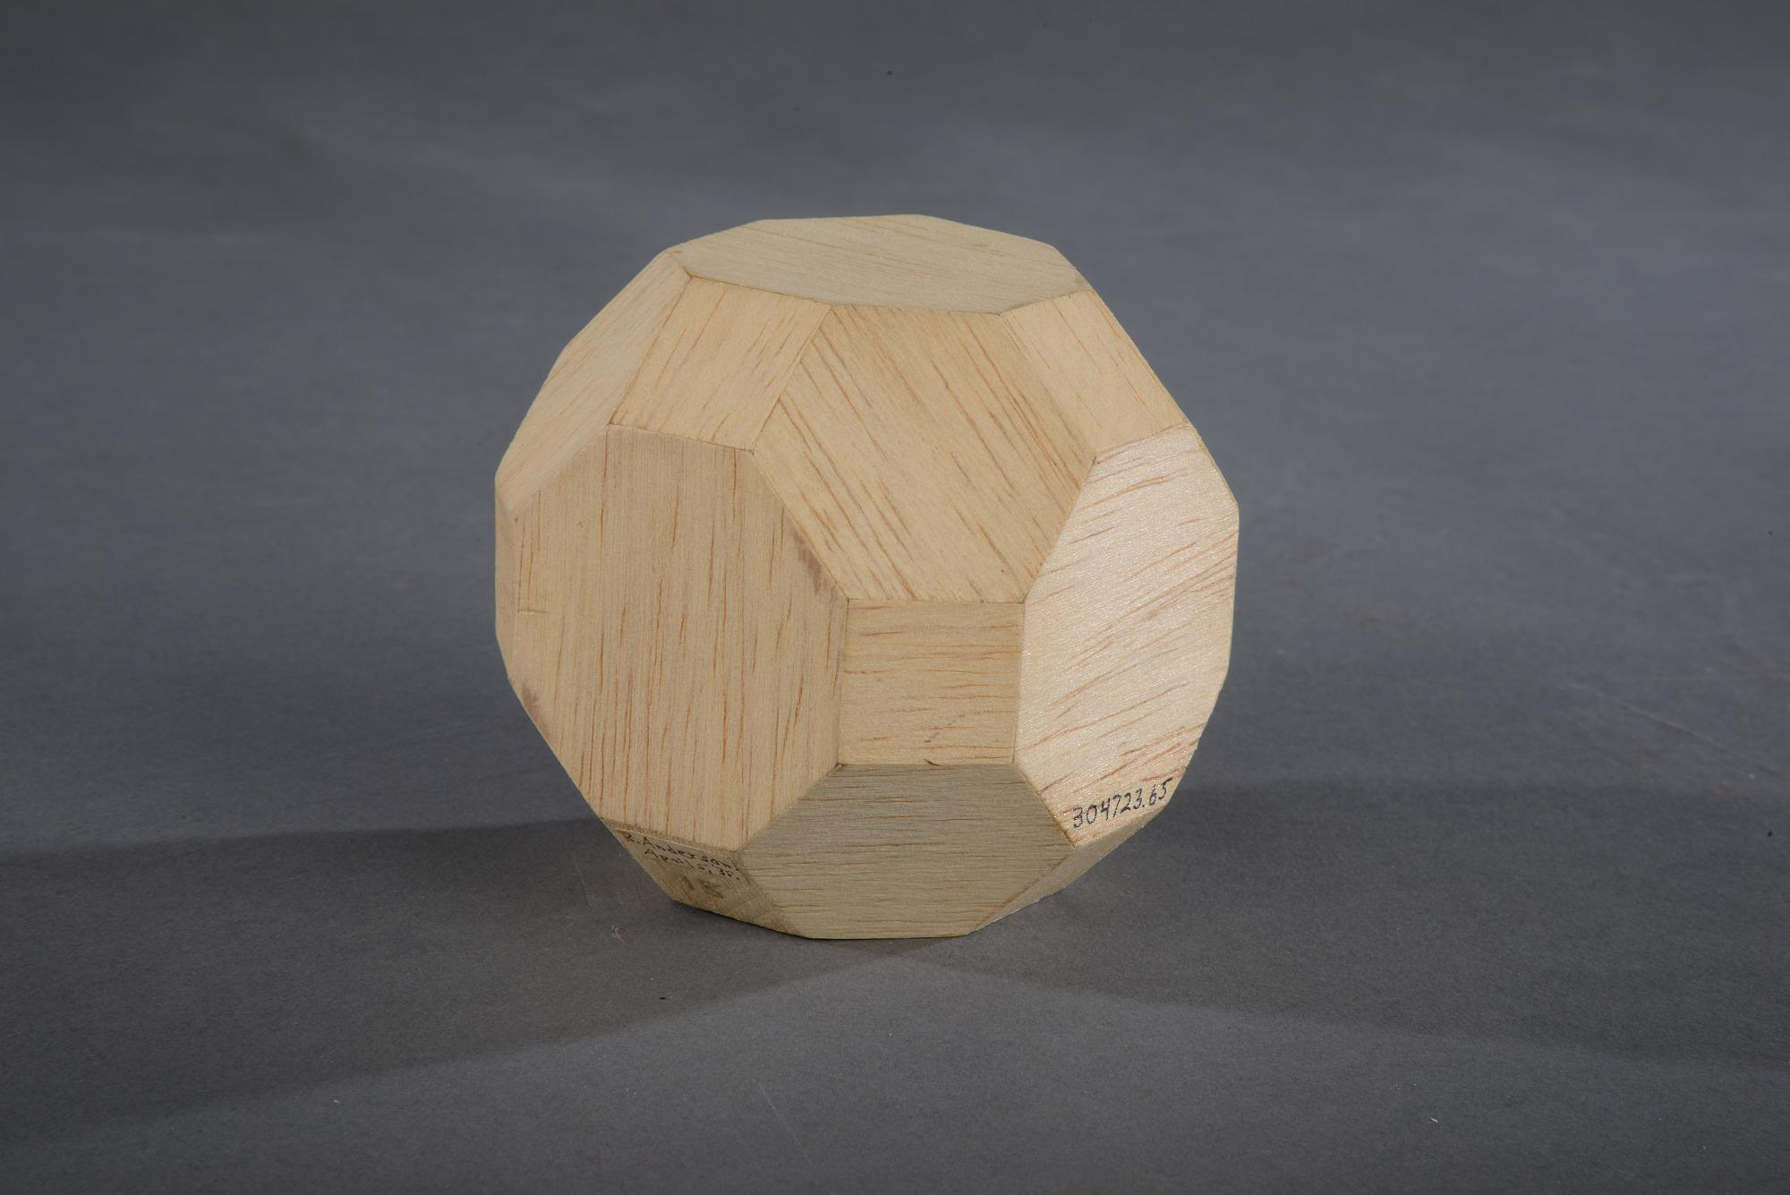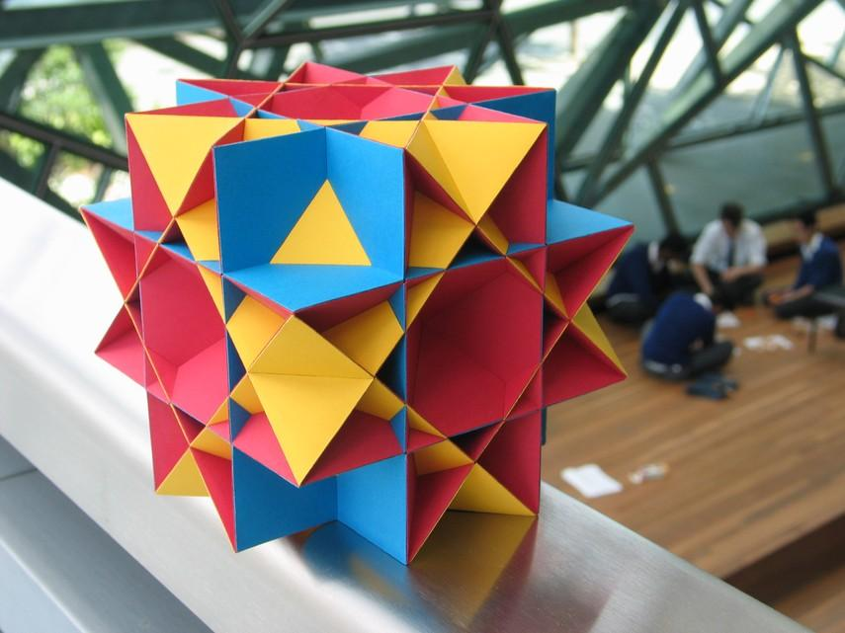
Step 1: Prepare the Spherical Blank
- Select a solid sphere with a suitable diameter.
- Determine the required edge length from the sphere's diameter:
$$a=\frac{D}{\sqrt{13+6\sqrt{2}}}$$
Step 2: Mark the Face Positions
- Identify the 12 square-face positions.
- Identify the 8 hexagonal-face positions.
- Identify the 6 octagonal-face positions.
- Use geometric templates and measuring instruments to mark the required face boundaries.
Step 3: Construct the Faces
- Cut or shape the 12 square faces.
- Cut or shape the 8 regular hexagonal faces.
- Cut or shape the 6 regular octagonal faces.
- Maintain equal edge lengths.
Step 4: Finish the Solid
- Smooth the face boundaries.
- Verify the face orientations and intersections.
- Check the 48 vertices and 72 edges.

Relationship to Other Geometric Solids
# Source: AI Source: Provided by: [Data Path: Persons Table -> ID Column: 1, Name_En Column: Motasem Essam] -> From: [ChatGPT] on [7/25/2026]
Truncated Cube
The convex hull of the Quasirhombicuboctahedron. It encloses all 24 vertices.
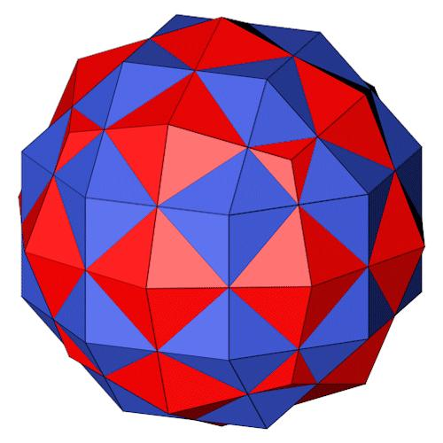
Great Deltoidal Icositetrahedron
The dual polyhedron, containing 24 dart-shaped faces.
Small Rhombicuboctahedron
A convex Archimedean solid sharing the same vertex-edge skeleton.
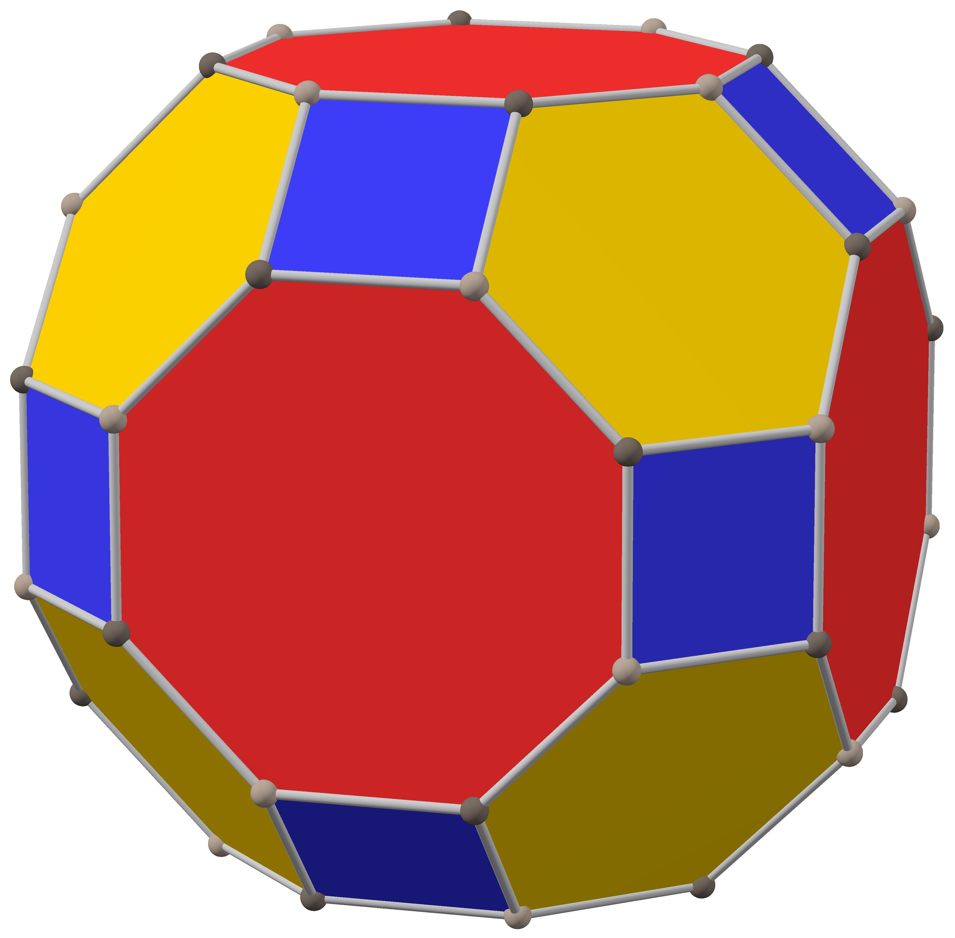
Convex Great Rhombicuboctahedron
A different Archimedean solid, also called the truncated cuboctahedron. It has 48 vertices, 72 edges, and 26 faces.

Comparison with Related Uniform Polyhedra
# Source: AI Source: Provided by: [Data Path: Persons Table -> ID Column: 1, Name_En Column: Motasem Essam] -> From: [ChatGPT] on [7/25/2026]
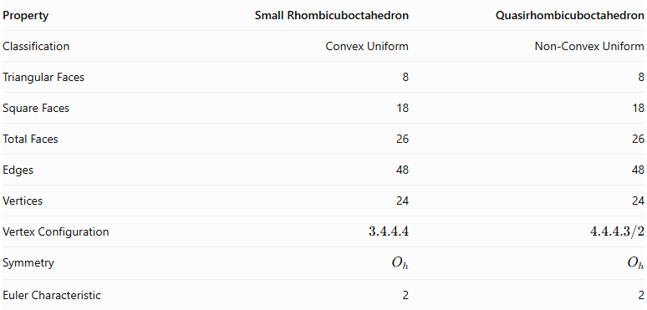
Property | Small Rhombicuboctahedron | Quasirhombicuboctahedron
Classification | Convex Uniform | Non-Convex Uniform
Triangular Faces | 8 | 8
Square Faces | 18 | 18
Total Faces | 26 | 26
Edges | 48 | 48
Vertices | 24 | 24
Vertex Configuration | $$3.4.4.4$$ | $$4.4.4.3/2$$
Symmetry | $$O_{h}$$ | $$O_{h}$$
Euler Characteristic | 2 | 2
The two solids have the same face counts, edge count, vertex count, and symmetry group, but differ in their spatial face arrangement and vertex configuration.

Main Classification
# Source: AI Source: Provided by: [Data Path: Persons Table -> ID Column: 1, Name_En Column: Motasem Essam] -> From: [ChatGPT] on [7/25/2026]
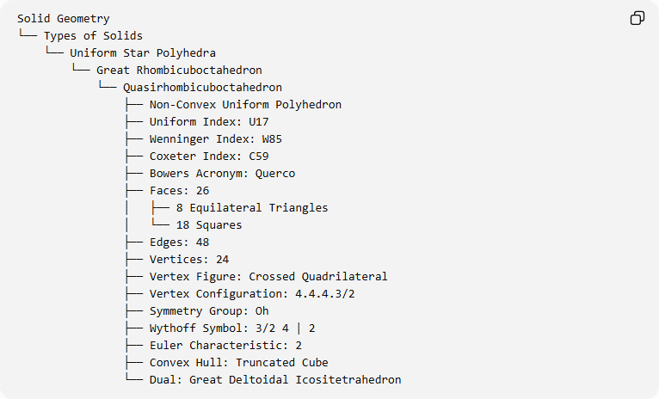
Solid Geometry
└── Types of Solids
└── Uniform Star Polyhedra
└── Great Rhombicuboctahedron
└── Quasirhombicuboctahedron
├── Non-Convex Uniform Polyhedron
├── Uniform Index: U17
├── Wenninger Index: W85
├── Coxeter Index: C59
├── Bowers Acronym: Querco
├── Faces: 26
│ ├── 8 Equilateral Triangles
│ └── 18 Squares
├── Edges: 48
├── Vertices: 24
├── Vertex Figure: Crossed Quadrilateral
├── Vertex Configuration: 4.4.4.3/2
├── Symmetry Group: Oh
├── Wythoff Symbol: 3/2 4 | 2
├── Euler Characteristic: 2
├── Convex Hull: Truncated Cube
└── Dual: Great Deltoidal Icositetrahedron

Key Points
# Source: AI Source: Provided by: [Data Path: Persons Table -> ID Column: 1, Name_En Column: Motasem Essam] -> From: [ChatGPT] on [7/25/2026]
- The non-convex Great Rhombicuboctahedron is also called the Quasirhombicuboctahedron.
- It is classified as U₁₇.
- It contains 26 faces: 8 triangles and 18 squares.
- It has 48 edges and 24 vertices.
- Its vertex figure is a crossed quadrilateral.
- Its vertex configuration is $4.4.4.3/2$.
- Its symmetry group is $O_{h}$.
- Its convex hull is the truncated cube.
- Its dual is the Great Deltoidal Icositetrahedron.
- It is distinct from the convex Archimedean Great Rhombicuboctahedron.

Conclusion
# Source: AI Source: Provided by: [Data Path: Persons Table -> ID Column: 1, Name_En Column: Motasem Essam] -> From: [ChatGPT] on [7/25/2026]
The Quasirhombicuboctahedron is a non-convex uniform polyhedron distinguished by its crossed vertex arrangement and its combination of 8 equilateral triangles and 18 squares. Although it shares its vertex-edge skeleton with the small rhombicuboctahedron, its different face arrangement produces a non-convex structure. Its symmetry, dual relationship, and classification as U₁₇ make it an important member of the uniform star polyhedra family.

